TASK:3-using attributes and anchor tag with refference of wekipedia

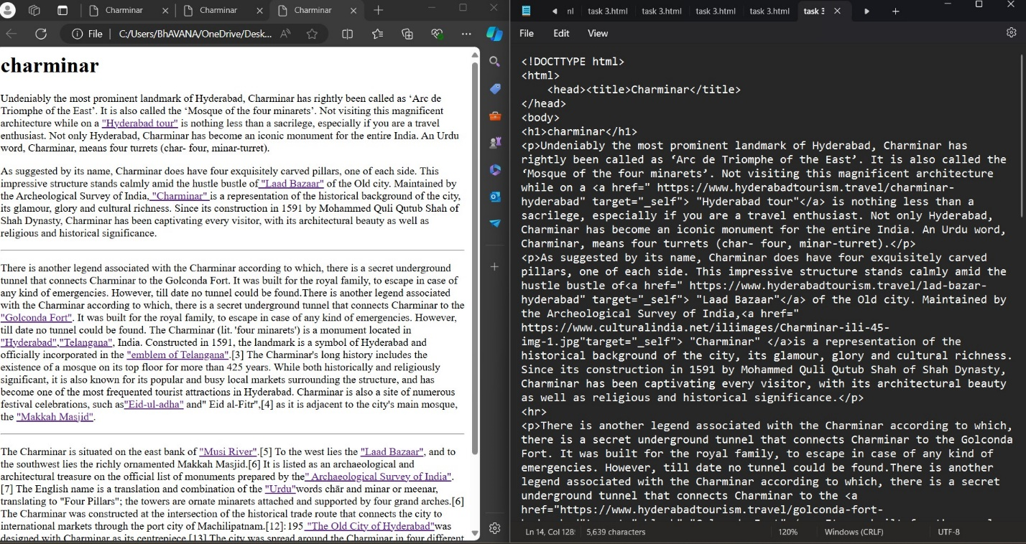

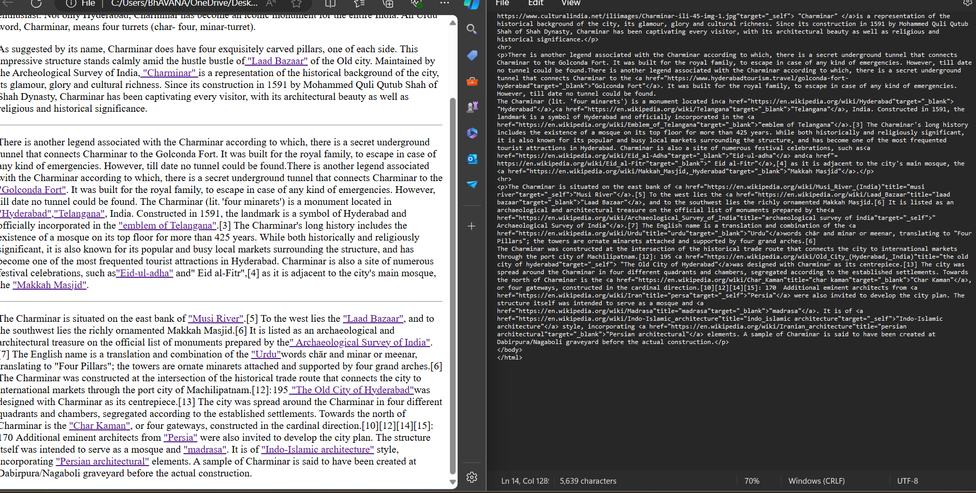

Task:<https://drive.google.com/file/d/1VFfAhse-3VOVf7J33rOoFOyqcW5mbWVz/view?usp=drive_link>

Task: [Charminar](file:///C:\Users\BhAVANA\OneDrive\Desktop\html\task%203.html)